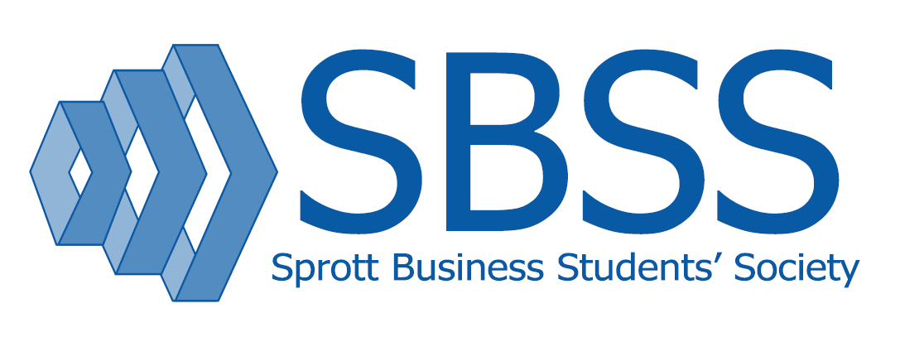
Internal Reimbursement
Form 2020-2021

Please complete the table and attach the receipts. If the receipts include non-reimbursable items, please highlight the items you are seeking reimbursement for. Reimbursement for expenses is done only if SBSS was unable to write a cheque or send an e-transfer in time for the event and is based on the approved budget; therefore, it is crucial for you to have submitted your budget to Kirsten at the beginning of the year.

All reimbursements must be accompanied by a receipt - no exceptions. Bank statements and confirmation of payment are NOT considered a receipt and will NOT be accepted. Reimbursement requests are due within two weeks of the event date. Any reimbursement not submitted after the before mentioned dates will not be reimbursed. Submit the form via email with the scanned receipts attached. Please allow for up to two weeks for your reimbursement once it is requested.

Please feel free to contact the SBSS VP Finance (Kirsten Josling) with any questions about reimbursable expenses, or for concerns at vpfinance@sbssonline.ca

Cheque/E-Transfer Payable To:

Email for Transfer (If applicable)
Name, Club and Position:
Event:
Date of Event and Date Reimbursement Submitted:

NOTE: ONLY ONE RECEIPT PER LINE
Date on receipt  (DD-MM-YY) | Detailed description of purchased items | Amount claimed | Do Not Write
 | TOTAL

PLEASE DO NOT WRITE ANYTHING BEYOND THIS POINT:
VP Finance approval & date:
Expense report reference: #
Cheque reference: #

